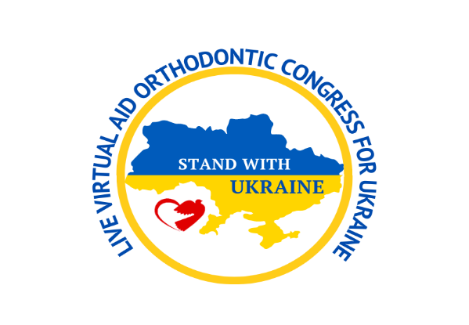

MONDAY, 11 JULY: ORTHOGNATHIC SURGERY & SMILE DESIGN
*Please note that the Congress begins at 8.00 AM (Pacific Time Zone USA)

8:00-9:00 AM FEDERICO HERNÁNDEZ ALFARO - SURGICAL MANAGEMENT OF CLASS II
9:15-10:15 AM MARIO POLO - TREATMENT ALTERNATIVES FOR EXCESSIVE GINGIVAL DISPLAY
10:30-11:30 AM SIMONAS GRYBAUSKAS - CORRECTION OF VERTICAL DEFORMITIES: LONG AND SHORT FACES
11:45-12:45 PM PAOLO MANZO -INTERDISCIPLINARY ORTHODONTICS, MANAGEMENT OF THE AESTHETIC AREAS
1:00-2:00 PM G.WILLIAM ARNETT - PROFILE TREATMENT PLANNING

TUESDAY, 12 JULY: TAD'S, SAGITTAL & PERIODONTAL CORRECTION

8:00-9:00 AM UTE SCHNEIDER - MANAGEMENT OF MISSING TEETH IN THE ANTERIOR AND POSTERIOR ZONE
9:15-10:15 AM LUIS CARRIERE- SAGITTAL FIRST AND LONG-TERM STABILITY. SIMPLIFYING TREATMENT OF SEVERE CLASS II AND CLASS III MALOCCLUSIONS
10:30-11:30 AM EWA CZOCHROWSKA - ORTHODONTIC PATIENT FOR GINGIVAL RECESSION
11:45 AM-12:45 PM CHRIS CHANG -MAXIMIZING SELF-LIGATION SYSTEM MECHANICS FOR CHALLENGING CASES
1:00-2:00 PM RAMESH SABHLOK - PREDICTABLE MAXILLARY MOLAR DISTALIZATION WITH MICRO-IMPLANTS FOR THE CORRECTION OF CLASS II MALOCCLUSION
2:15-3:15 PM MAURO COZZANI - CLASS II: BACK OR FORTH?

WEDNESDAY, 13 JULY: TAD'S, SURGICAL & NON-SURGICAL EXPANSION
8:00-9:00 AM JAMES MCNAMARA – ORTHODONTIC & ORTHOPAEDIC CORRECTION OF TRANSVERSE PROBLEMS IN THE MIXED & PERMANENT DENTITION: A 40 YEAR PERSPECTIVE
9:15-10:15 AM WON MOON - NON-SURGICAL MANAGEMENT OF EXTREME VERTICAL PROBLEMS (OPEN & COLLAPSED VERTICAL FACIAL HEIGHTS) WITH TAD'S
10:30-11:30 AM JUAN CARLOS PEREZ VARELA - SKELETAL ANCHORAGE AND MALOCCLUSION, WITH 3D DIAGNOSIS
11:45 AM-12:45 PM HEINZ WINSAUER - SUCCESSFUL SURGERY FREE MAXILLARY EXPANSION IN 8 OUT OF 10 ADULTS DUE TO A FORCE DEPENDENT POLYCYCLIC ACTIVATION PROTOCOL AND A PURE BONE BORNE EXPANDER
1:00-2:00 PM BENEDICT WILMES - ALIGNMENT OF IMPACTED TEETH USING SKELETAL ANCHORAGE

THURSDAY, 14 JULY: TMD & MIOFUNCTIONAL THERAPY

8:00-9:00 AM NICKY MANDALL – DOES EARLY CLASS III PROTRACTION MASK REDUCE THE NEED FOR ORTHOGNATHIC SURGERY
9:15-10:15 AM PATRICK FELLUS - AN INNOVATIVE APPROACH TO REHABILITATION AND AUTOMATIZATION OF ORO-FACIAL PRAXIS IN ORTHODONTICS THROUGH THE LOWER BRAIN
10:30-11:30 AM ALADIN SABBAGH - ADVANCED TMD & INTERDISCIPLINARY OCCLUSAL REHABILITATION
11:45 AM-12:45 PM MICHAEL MEW - WHAT CAN WE DO TO PREVENT OR MINIMISE MALOCCLUSION
1:00-2:00 PM MAURICIO GONZALEZ BALUT -CONTEMPORARY TECHNOLOGY FOR DIAGNOSIS AND TREATMENT OF THE TMJ

FRIDAY, 15 JULY: ALIGNERS & DIGITAL ORTHODONTICS

8:00-9:00 AM KENJI OJIMA - ADVANCED ALIGNER ORTHODONTIC
9:15-10:15 AM MAURICIO ACCORSI - THE NEXT STEP IN DIGITAL ORTHODONTICS - PROTAGONIST, OR PUPPET?
10:30-11:30 AM RAVINDRA NANDA - BIOMECHANICS OF ALIGNERS: HOW TO ENHANCE TREATMENT OUTCOMES
11:45-12:45 PM JOSE IGNACIO GUERRA HOLGUÍN - HOW TO USE ULAB SYSTEMS, A DIGITAL PLATFORM BASED ON AI TO CREATE 3D INVISIBLE ALIGNERS
1:00-2:00 PM DOMINGO MARTIN - FAS(FACE ALIGNER SYSTEM) - INTRODUCING FUNCTION IN THE WORLD OF ALIGNERS
2:15-3:15 PM WILSON LEE - MYTHS AND FACTS OF INVISIBLE ORTHODONTIC APPLIANCES - WHERE ARE WE NOW?

